**Topic One: Chemistry of Living Things**

1. All living things must maintain ___________in order to stay alive.
   1. **Homeostasis**: A _________state in the body.
   2. Failure to maintain homeostasis results in _________or death.
   3. Homeostasis is often maintained using __________mechanisms.
      1. Feedback mechanisms are ________in which the product of one reaction causes another to start or stop.
   4. While organisms are balanced, they are not unchanging. The term used to describe the balanced state is____________________**.**
      1. **Dynamic Equilibrium:** A balanced state created by many small, ___________changes.



**Word Bank:** feedback opposing dynamic-equilibrium cycles disease balanced homeostasis

1. **Life Processes:** All living things carry out the same basic chemical____________. Taken together, these process make up an organism’s____________.
   1. **Metabolism:** All chemical processes used to maintain______________.
      1. **__________:** Using nutrients for growth, synthesis, repair and energy.
      2. **__________:** Converts energy in food into a usable form (ATP).
      3. __________: Making complex chemicals from simple substances.
      4. __________: Absorbing and distributing materials throughout the body.
      5. __________: The control and coordination of life processes.
      6. __________: Removing of wastes produced by metabolic activities.
      7. __________: Passes on genes to offspring.

**Word Bank**: homeostasis processes metabolism reproduction excretion regulation transport synthesis respiration nutrition

1. **Inorganic Chemicals**: ________compounds
   1. _________ ( H2O) : Most common substance in all living things (about 60% of body mass)
      * + Needed for chemical __________(won’t happen in “dry” conditions)
        + Dissolves other molecules into__________**,** allowing them to be **transported** through the body.
   2. _________ (O2): Needed by **most** (not all) organisms for **cellular respiration**.
      * + Released by plants and algae as a waste product of_____________**.**
        + **Aerobic respiration:** Process that uses oxygen to extract __________from glucose (sugar). Used by most organisms.
        + Anaerobic respiration: Process that extracts energy from glucose __________using oxygen. Gives __________energy, so only used by some simple organisms (some bacteria, yeast). These organisms do not need to __________in oxygen.

**Word Bank**: solution reactions water simple breathe without less energy oxygen photosynthesis

* 1. **Carbon Dioxide** (CO2): With water, used by plants to make glucose (**photosynthesis)**.
     + - Waste product of____________________.
  2. **Nitrogen** (N2): Most common gas in air (70%)
     + - Needed to make___________.
       - Converted into ___________by soil bacteria. Nitrates are ___________by plants and then eaten by animals.
       - Excreted as waste in ammonia or ___________.
  3. Acids and Bases: Used for different functions in body (such as digestion).
     + - Measured by the __________scale
       - Very high and very low pHs are usually___________.
       - pH can affect rates of chemical reactions; for example, digestive _________work fastest in acidic environments, which is why we make stomach __________(hydrochloric acid, or HCl).

**Word Bank**: urea absorbed nitrates protein acid enzymes lethal pH aerobic-respiration.

1. **__________Compounds**: Larger, more complex chemicals. Always contain the elements like carbon (C)and hydrogen (H). Synthesized from simpler substances (building blocks).
   1. **Carbohydrates:** Sugars and______________.
      1. **Building blocks**: simple______________.
      2. Functions:
         * _____________energy.
         * _____________energy (starch in plants).
   2. **Lipids:** fats, _________and waxes.
      1. Functions:
         * Store energy.
         * Cell membrane.
         * Water_____________.
         * ___________________.

**Word Bank**: store provide sugars starches organic oils proofing insulation

* 1. **___________:** Complex compounds that carry out all the body’s activities.
     1. **Building blocks:** _____________.
     2. After water, proteins are the most __________substances in the body.
     3. Have many different functions as determined by their______________.
     4. **Lock and _______Model:** Proteins must have the right shape to “___” with other molecules.
        + **Changing the shape of a protein will change what it can interact with its__________.**
     5. Important types of proteins:
        + **Hormones** and **neurotransmitters** – carry ___________through the body.
        + Cell receptors – in cell membrane; __________hormones and neurotransmitters.
        + Antibodies –____________foreign **pathogens**
        + **Enzymes**- act as **catalysts**, ________________all chemical reactions in the body.
          - High temperatures will cause enzymes to denature (lose their shape) and stop_____________. This is why high fevers are__________________.
  2. **Nucleic Acids (DNA and RNA)**: Make up ___________and chromosomes.
     1. **Building blocks**: Nucleotides; molecular _____________(ATCGU)

**Word Bank**: functioning dangerous controlling attack receive messages genes bases function key fit shape plentiful amino-acids proteins enzyme

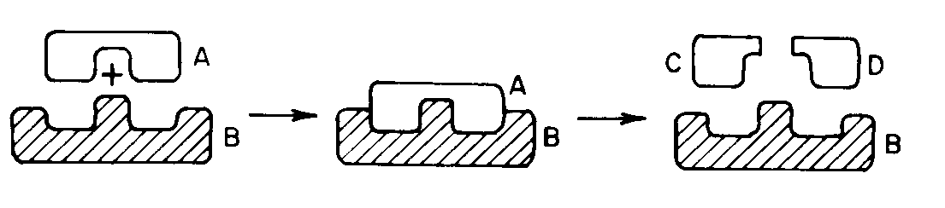

A starch (A) is broken down by an ___________(B) into two simple sugars (C, D). This is also a good example of the **lock and key model**.

**Topic Two: The Cell**

1. **Definition:_____________________________________________**.
2. **Cell Theory**  has three parts:
   * 1. _______________________________________________.

Unicellular – single celled organisms (amoeba, paramecium)

Multicellular – have more than 1 cell; may be only a few (vorticella), or many *trillions* of cells (humans). Almost all structures in multi-celled organisms are made of or by cells.

* + 1. _______________________________________________.

Everything you do is the result of the work of your cells – walking, talking, even thinking and feeling. When you get sick, it is because your cells are not working correctly.

* + 1. _______________________________________________.

This seems obvious now, but at one time people believed in *spontaneous generation*, the idea that living things regularly emerged from nonliving things.

* 1. **Exceptions to the Cell Theory**
     1. _____________are not made of cells. However, they also do not carry out all life processes, so many biologists do not consider them true living things.
     2. _____________obviously could not come from another cell.

1. **Organization**

__________– A cell part

**Cell**

__________– A group of specialized cells

__________– Group of tissues that work together

__________– Group of organs that work together

**Word Bank**: viruses tissue organ organ-system organelle The-first-cell

All life functions are the result of the cell activities

All cells come from pre-existing cells.

All organisms are made of one or more cells

basic unit of structure and function in an organism

1. **Cell Organelles:** These are the tiny cell parts that make up a cell.
   * 1. **_______________**
        + 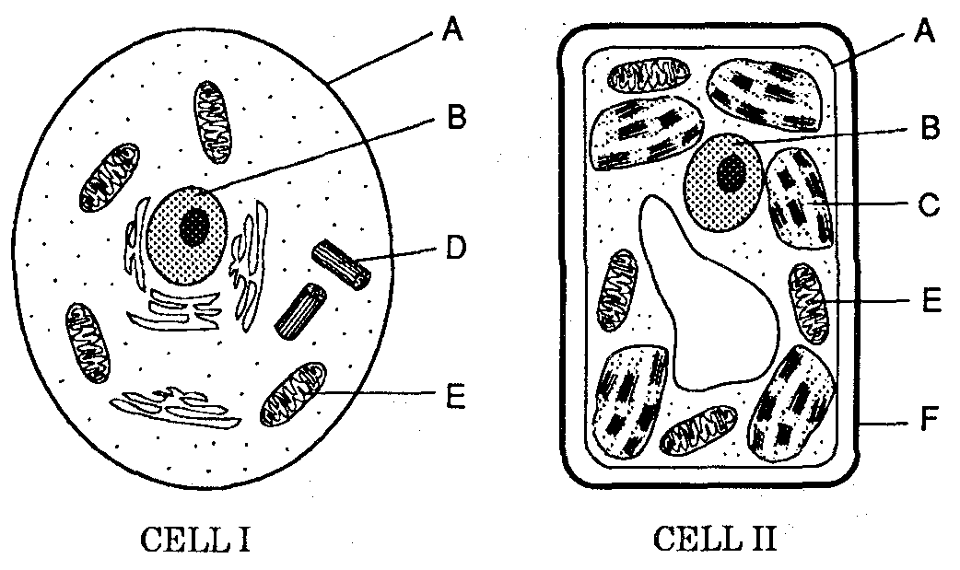Controls the cell
        + Contains hereditary material (chromosomes, genes, DNA)
     2. **_______________**
        + Fluid/liquid in the cell – mostly water
        + Helps transport material
     3. **_______________**
        + Carries out cellular respiration.
        + Gives cell energy (Powerhouse of the cell).
     4. **_______________**
        + Makes proteins from amino acids.
     5. **_______________**
        + Stores food, water and waste
        + Food vacuoles may digest large molecules.
        + Waste vacuoles may excrete waste out the cell membrane
     6. **________________**
        + Carries out **photosynthesis**
        + Plant and algae cells only
     7. **________________**
        + Gives shape, structure and protection.
        + NEVER found in animal cells.
     8. **________________**
        + Separates cell interior from environment
        + Controls what enters and leaves the cell using______________**.**
        + Has ____________________that pick up signals from other cells.

Has **_____________** which are proteins that identify the cell; prevent the cell from being attacked by the immune system.

**Word Bank:** antigens transport chloroplast cell-wall receptor-proteins cell-membrane vacuole ribosome mitochondrion cytoplasm nucleus

**Topic Three: Nutrition, Photosynthesis and Respiration**

**Reminder:** All life processes are **chemical activities** which make up your____________.

1. **Nutrition**: Taking in nutrients (________) for various activities including:
   * 1. Respiration (_________)
     2. Growth
     3. Repair
     4. ___________
   1. **Ingestion: ______________________________.**
   2. **Digestion**:______________________________.
      1. Nutrients must be broken down into smaller parts so that they can be _______________into the blood and cells of organisms.
         * Starches are digested into_____________.
         * Proteins are digested into______________.

**Word Bank:** amino-acids absorbed sugars synthesis taking-in-nutrients

metabolism breaking down-nutrients food energy

* 1. **Autotrophic Nutrition:** Organisms take ____________materials (______**,** H2O) and convert them into organic nutrients (___________).
     1. Auto =________; troph = _________so Autotroph = __________.
     2. ________________is most common form of autotrophic nutrition
     3. **Ex:** plants,___________**.**
  2. **Heterotrophic Nutrition:** Organisms must _______________nutrients made by other organisms.
     1. Hetero =___________, so Heterotroph =_____________________.
     2. All __________and __________are heterotrophs.
     3. Includes:
        + _______________: consumes animals.
        + _______________: consumes plants.
        + _______________: consumes both.
        + _______________: breaks down dead matter.

**Word Bank:** other fungi animals consume feeds-on-others self photosynthesis self-feeding glucose simple-organic decomposers CO2 omnivore herbivore carnivore other feeding algae

1. **Photosynthesis:** Process in which sun’s energy is trapped in the chemical _________of sugar.
   1. Requires__________, **CO2** and **H2O**.
   2. Makes ___________(**C6H 12O6**) as food.
   3. __________and __________are waste products.
   4. 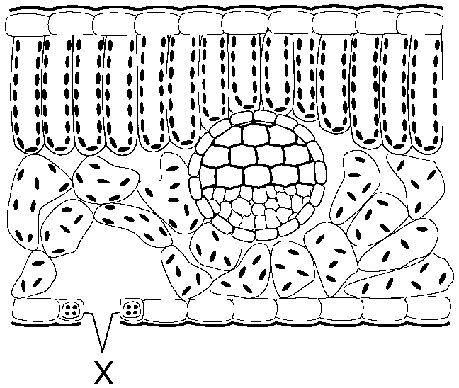Benefits:
      1. Provides ___________for all plants, animals and other organisms.
      2. Provides oxygen to_____________.
      3. Removes ______________from atmosphere.
   5. Plant adaptations:
      1. **Chloroplast**: Cell organelle that does_________________**.**
      2. Gas exchange:
         * **Stomata :** _____________under a leaf; let gases in and out
         * **Guard cells:** open and close stomata to prevent__________________.
      3. Transport:
         * 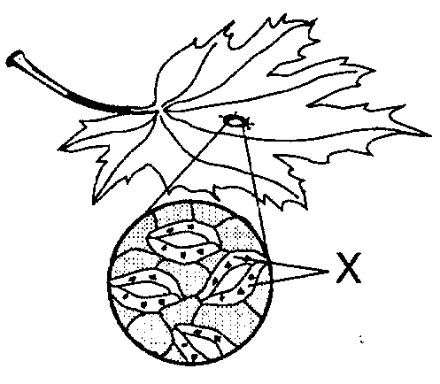**Xylem and Phloem:** “tubes” ___________food and water throughout the plant.

**Word Bank**: photosynthesis transport dehydration holes oxygen water carbon-dioxide bonds glucose sunlight food stomates

Two different views of the ________and their **guard cells** (X)**.**

1. **Cellular Respiration:** Process that takes **___________**from sugar molecules and places it in molecules of__________**.**
   1. ATP is the ___________all life uses for **energy**.
      * + No organism can get energy from ___________or sugar without first putting the energy into ATP.
   2. Requires___________, oxygen and water.
   3. ____________and __________are waste products.
   4. Most organisms carry out **aerobic respiration** (uses oxygen) in their_____________________.
   5. **_____________respiration** does not require oxygen, but gives less ATP (energy) for each molecule of sugar.
      * + When exercise causes human muscles to run out of____________, their cells will do **anaerobic respiration**. The waste product, ______________, causes muscles to “burn” so that you will **stop**.

**Word Bank**: ATP molecule energy glucose lactic-acid sunlight carbon-dioxide water mitochondria anaerobic

* 1. 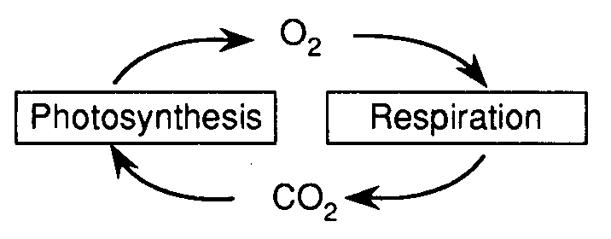**Photosynthesis and Cellular Respiration are ______________reactions!** They are also important in _____________oxygen, carbon, hydrogen and water through the environment.

____________________

____________+ CO2 + H2O 🡪 glucose + O2 + H2O

_____________________

glucose + O2 + H2O 🡪 CO2 + H2O + _________

* 1. **Common mistakes:** 
     + - “Plants use photosynthesis, animals use respiration.”

*All organisms, including plants, use respiration to get their_______________.*

* + - * “Respiration is breathing.”

*Breathing is* ***not*** *respiration. Breathing ________________the gases needed for respiration. Inhaling and exhaling does not give you ATP.*

* + - * “Oxygen is used to breathe.”

*This is backwards. Breathing is used to get oxygen which is used for respiration. Without oxygen, you have no_________________, no ATP, and no energy.*

* + - * “All living things need oxygen/need to breathe.”

*Anaerobic organisms do not need oxygen, and do not have to________________.*

**Word Bank**: cycling opposite exchanges energy respiration ATP sunlight cellular-respiration photosynthesis breathe

**Topic Four: The Human Body**

1. **Organization:** The human body is made up of____________.
   1. All humans (and most other organisms) begin life as a ___________cell.
      1. This single cell is called a_____________.
      2. The nucleus of this cell has _______the genes needed to become a complete organism.
   2. Humans grow as a result of ___________cell division).
      1. This quickly increases the number of cells in the body until there many _________of cells.
      2. Since all new cells come from the same single cell, they all share the same__________.
   3. As cells divide, they begin to develop into specialized___________.
      1. ________________or **Differentiation:** Process in which a cell changes to have a special shape and function.
      2. Cells specialize by __________specific genes on or off.
         * Ex: A ___blood cell has turned off all genes needed to make skin, bone, or nerves. It still has those genes, but only the genes ______to be a white blood cell remain turned on.
   4. As the body continues to develop, tissues will work together to form__________.
   5. Organs will work together to form__________________.
   6. Org an systems will work together to help a person **maintain________________**.

**Word Bank**: trillions cells single tissues zygote needed white all mitosis specialization genes homeostasis organs turning organ-systems

1. **Nervous System**
   1. The nervous system __________your body with electrochemical______________.
      1. The chemical portion of a nerve impulses is called a______________.
      2. Neurotransmitters released by 1 nerve cell are received by ____________in the cell membrane of the next nerve cell.
      3. The __________of the receptor molecule determines which neurotransmitter it can receive.
   2. A nerve cell is also called a____________.
   3. The main organs of the nervous system are the _______and_____________.
   4. The **spinal cord** controls __________and relays impulses between the brain and body.

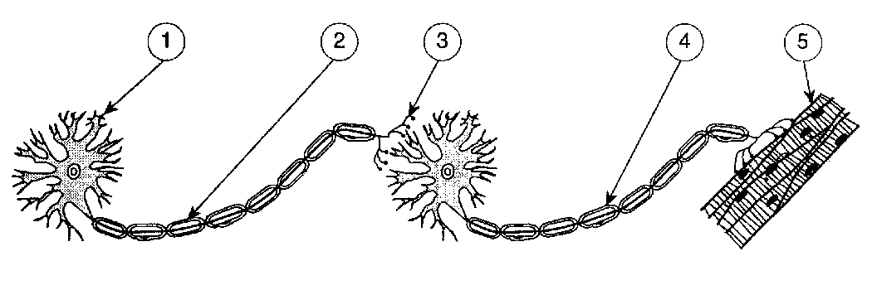

**Two neurons** carry an impulse to a _____cell. (3) shows where a **neurotransmitter** would carry the _________from one cell to the next.

**Word Bank:** shape regulates reflexes impulses neurotransmitter receptor-proteins muscle neuron brain signal spinal-cord

1. **Endocrine System**
   1. Uses **_____________**to **regulate** thebody.
      1. 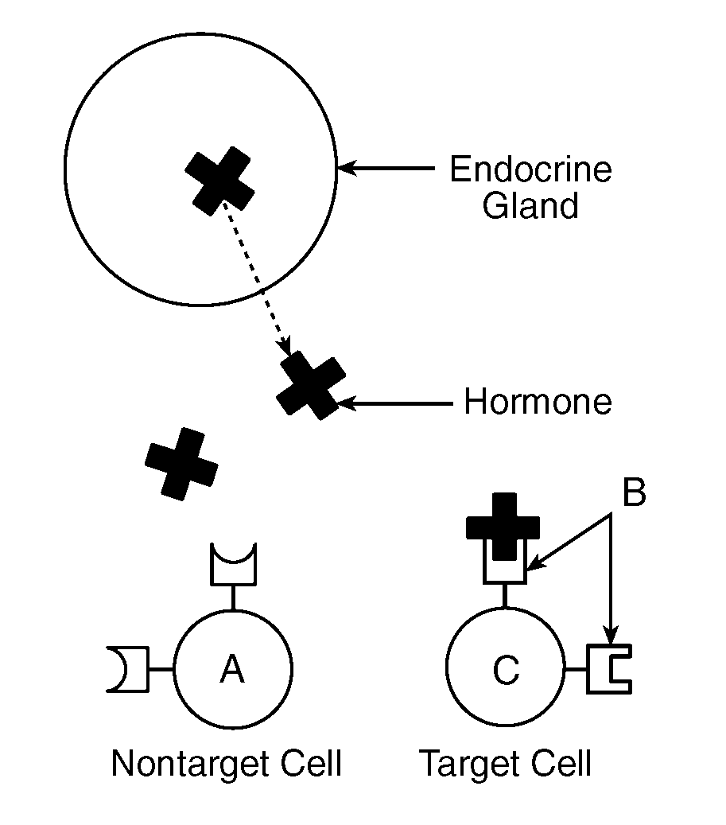A hormone is a chemical ____________secreted by endocrine **glands.**
      2. Hormones are slower than nerve impulses, but with _________lasting effects.
      3. Hormone levels are controlled by ____________**mechanisms**.

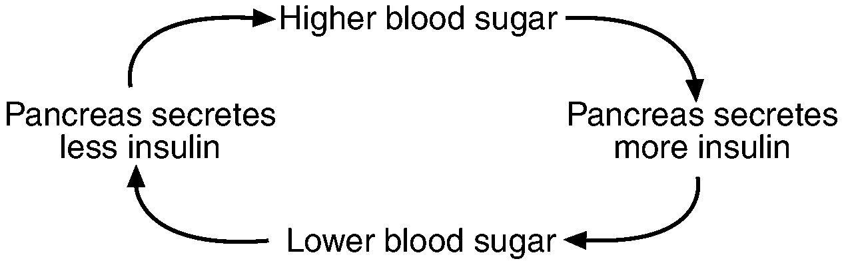

**Receptor Molecules** in the cell membrane can only accept ________of the correct shape. This is a good example of the **Lock and Key Model.**

**A feedback mechanism**

* + 1. **__________molecules** on the surface of the cell membrane receive hormones. **As with all proteins, it is the _____________of the receptor molecule that determines which hormone it can receive.**
  1. The ___________makes ___________and glucagon which control blood sugar.
     + - **Common mistake:** “Insulin lowers blood pressure.”

*Insulin (and glucagon) directly control blood __________(or glucose) levels, not blood pressure.*

* 1. Adrenal glands make _____________when the body is under stress.
  2. **Testosterone** (male), **estrogen** and **progesterone** (female) are the sex hormones. These are made in the ____________(testes for males, ovaries for females).

**Word Bank**: longer hormones feedback messenger receptor shape pancreas gonads insulin adrenaline sugar molecule

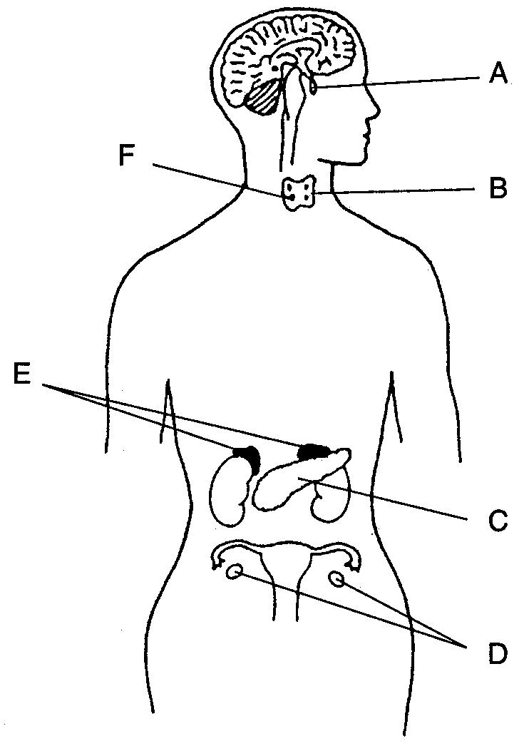

**The brain (nervous system) and some endocrine glands.**

# Circulatory System

# Moves ___________through the body to the organs and cells that need them.

* 1. Transported material includes:
     1. ___________and __________from **intestines** to all cells of body.
     2. __________from lungs to all cells of the body.
     3. ___________from glands to target cells
     4. ___________from all cells to the **excretory organs.**
  2. Materials usually enter and leave the blood through___________**.**
     1. **Diffusion**: Process in which material moves from a ___concentration to a low concentration.
        + **Ex**: There is a high concentration of oxygen in the lungs, so oxygen will diffuse from the lungs into the_________, which has less oxygen.
     2. **___________:** Microscopic blood vessels where diffusion occurs.

## The __________is the pump that drives the circulatory system.

## ________________carry oxygen and carbon dioxide

* + 1. Hemoglobin: ____________in red blood cells that carries oxygen.
  1. _____________is the fluid of the blood. It transports everything *except oxygen*.
  2. Platelets ___________the blood.

## Common mistakes:

### “The heart pumps oxygen to the brain.”

### *Technically true, but the heart pumps blood (which carries the oxygen) ________________in your body.*

### “Oxygen diffuses into and out of the heart.”

### *No materials _____________in or out of the blood when it is in the heart. This __________occurs in capillaries.*

**Word Bank**: material nutrients water protein high diffusion oxygen hormones wastes clot capillaries heart blood red-blood-cells everywhereplasma diffuse only white-blood-cells

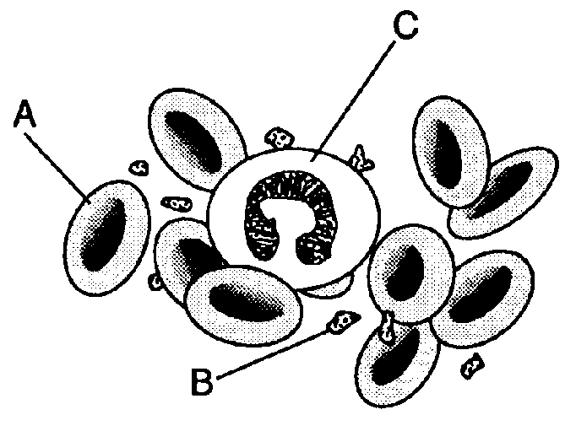

Red blood cells (A), platelets (B) and ________________(C)

**.**

# Respiratory System:

## Breathing provides ____________needed for cellular respiration (which uses energy from sugar to make__________).

## Excretes the waste __________which is produced from cellular respiration.

## The _____________is the muscle that allows breathing to occur.

## You breathe faster when CO2 builds up in the ___________(not when you need oxygen).

## The __________are microscopic sacs where oxygen enters the blood and CO2 leaves the blood.

## The alveoli are surrounded by __________which pick up oxygen and drop off CO2.

## Word Bank: diaphragm capillaries oxygen ATP alveoli blood CO2

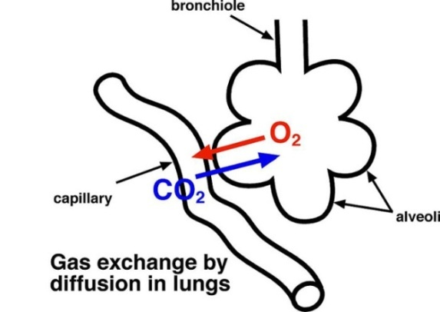

1. **Digestive System:** 
   1. Food is ___________down so that it is small enough to enter the body tissues/cells.
      1. Food is broken down mechanically and_______________.
      2. Nutrients and water are ____________into the body in the small and large intestines.
   2. The digestive system is a one way _________through the body that includes the **mouth**, **stomach** and **intestines**.
   3. Food is moved through the digestive system by muscular contractions (___________).
   4. Undigested food is _____________as solid waste (**feces**).
   5. Common mistakes:
      1. “The digestive system excretes waste.”

*The digestive system does not excrete waster (see excretory system)*.

* + 1. “The digestive system gives you energy.”

*The digestive system gives_____________. Energy is gained by cellular respiration.*

**Word Bank:** passage chemically nutrients absorbed peristalsis broken eliminated excretes

## Excretory System:

## 0000663Removes waste produced by the ___________of your body.

## These wastes include _______,__________,_________ and_________.

## Lungs excrete _________and__________.

## The skin excretes _______and _______as sweat.

## The kidneys excrete _______and _______and other substances as urine.

**Kidneys and Urinary Tract**  - part of the human excretory system.

## ___________also control the amount of water in your body.

## The _____________filters toxins and dead red blood cells from the blood.

## Common mistake:

## “The body excretes feces.”

## *Feces never enters cells of the body, so technically it is not excreted. The correct term is “______________” or “egested.”*

**Word Bank**: cells salt (2) water (4) urea (2) liver CO2 (2) kidney eliminated excretory

1. **Immune System**
   1. The job of the immune system is to protect the body against______________.
   2. **Pathogen:**  _________________.
      1. Types of pathogens include viruses, bacteria, and______________.
   3. **_____________Blood Cells** are the main components of the immune system.
      1. Different w.b.c’s have different roles, including:
         * ____________pathogens.
         * “____” pathogens for destruction by other wbc’s.
         * Destroy pathogen by __________it.
         * Destroy pathogen using__________**.**
         * Make____________**.**
   4. **Antibodies** are _______________made by white blood cells to attack pathogens.
      1. Every antibody is specific in its__________– it can attack one and only one _________of pathogen. As with all proteins, this is because the shape of the antibody must fit its __________(lock and key model).

**Word Bank**: parasites identify pathogens disease-causing-organism tag white chemicals proteins eating antibodies action type target

* 1. **Antigens** are protein “______” that identify a cell or virus.
     1. Your blood type is determined by your _________(you can have A or B antigens, both or nether (type O).
     2. Any cell of virus with the wrong antigen will be seen as ________by your immune system, attacked, and destroyed. This is why you must match blood types before receiving blood or an organ__________.
  2. **A ___________is an injection of a dead or weakened pathogen.**
     1. Triggers the body to make antibodies __________that pathogen.
     2. Effective against both __________and bacteria.
     3. Can only _________disease, not cure it.
  3. __________are drugs used to stop infections by **bacteria**.
     1. Antibiotics will not _________against viruses.
     2. Unlike vaccines, antibiotics can _________diseases.
  4. **Common mistake:**
     1. “Antibodies are cells that attack pathogens.” *Antibodies are_________, not cells.*

**Word Bank**: tags vaccine foreign antibiotics antigens transplant prevent cure against viruses work proteins

1. **Interactions between body systems**
   1. The different systems of the body work together to maintain homeostasis. For example:
      1. *Nutrients from the __________system are transported to cells by the __________system.*
      2. *Wastes from the ________system are removed by the _________system.*
      3. *The ________and _________systems work together to control the body.*
      4. *The ________system protects the __________system from disease.*

**Word Bank**: respiratory immune nervous (2) endocrine excretory circulatory digestive

1. **Diseases and Disorders**
   1. Typically the exam asks you to name a disease, what ________it, its effect on the_______, and how to prevent/treat/cure it. The most important diseases and disorders for you to know are:
      1. **AIDS**
         * Caused by the _______virus (a pathogen)
         * Weakens human immune system, leaving body ___________to other diseases.
         * Spread through bodily___________, usually sexual contact, intravenous (IV) drug use (sharing needles), or blood___________.
         * Can’t be cured, but spread may be ___________by sexual abstinence, “safe” sex (using condoms), not sharing needles, or __________blood before using it for a transfusion.

**Word Bank**: HIV transfusions causes prevented vulnerable fluids testing body

* + 1. **Cancer**
       - Caused when a cell reproduces (divides) at an __________rate, forming a **tumor**.
       - Cancer cells **do not specialize** and take ___________from healthy tissue.
       - May be caused by_______, chemicals (such as asbestos or cigarette smoke), and viruses.
       - Treatments include surgery, radiation therapy, and_____________.
    2. **Diabetes**
       - Affects body’s ability to control blood______________.
       - Some diabetics may be treated using injections of __________made by genetically engineered bacteria.
    3. **Allergies**
       - Occur when the immune system __________to a harmless substance (such as pollen)
       - _______________is a form of allergy caused by a reaction to dust particles in the air.

**Word Bank**: radiation sugar chemotherapy insulinuncontrolled resources reacts asthma

**Topic Five: Reproduction**

1. **Asexual reproduction:** 
   1. Advantages: _______________________________
   2. Disadvantage: _______________________________
2. **Sexual reproduction:** 
   1. Advantage: _______________________________________
   2. Disadvantage: _____________________________________

**Word Bank**: slower-harder-risker no-variety faster-easier-safer variety

1. **Mitosis**
   1. Used in all forms of ___________ reproduction.
   2. The number and types of chromosomes in the daughter cells are ______________ as in the parent cell.
   3. 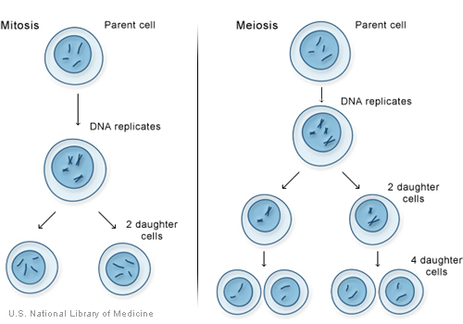Large organisms use mitosis for ___________and _____________. Simple organisms use it to _____________.
   4. One division of a cell 🡪 two identical, ________ (2n) cells.
      1. Diploid: Cell with a ________ sets of chromosomes.

**Mitosis vs. Meiosis.** Notice the number of _________________ stays the same in mitosis, and is halved in meiosis.

1. **Meiosis**
   1. Makes ______________ used in sexual reproduction.
      1. Gamete: _______ cells; egg and sperm
   2. One cell divides *twice* 🡪 four DIFFERENT _________ (1n) cells.
      1. Haploid: Cell with __________ set of chromosomes ( ½ normal)
   3. Separates pairs of chromosomes so that offspring get ________ chromosome of each pair from that parent.
   4. Each daughter cell (gamete) gets only one half of the chromosomes of the “__________” cell.

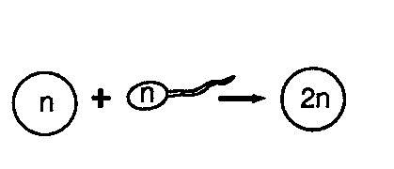

**Word Bank**: two the-same healing growth gametes one asexual one reproduce diploid sex haploid parent chromosomes

1. **Male Reproductive System**
   1. Testes produce and _________ sperm.
      1. Sperm are haploid cells made by ______________
      2. Sperm are produced in large numbers throughout a males _______________.
      3. Sperm are _________ than the egg and mobile
      4. Sperm only provide offspring with 23 chromosomes – everything else is in the _________.
   2. Testosterone is the male sex hormone, and is made in the ____________.
   3. Penis transfers ____________ into the female reproductive system.
   4. Semen is the _________ that carries sperm.
      1. Semen contains sugar to give sperm ____________.

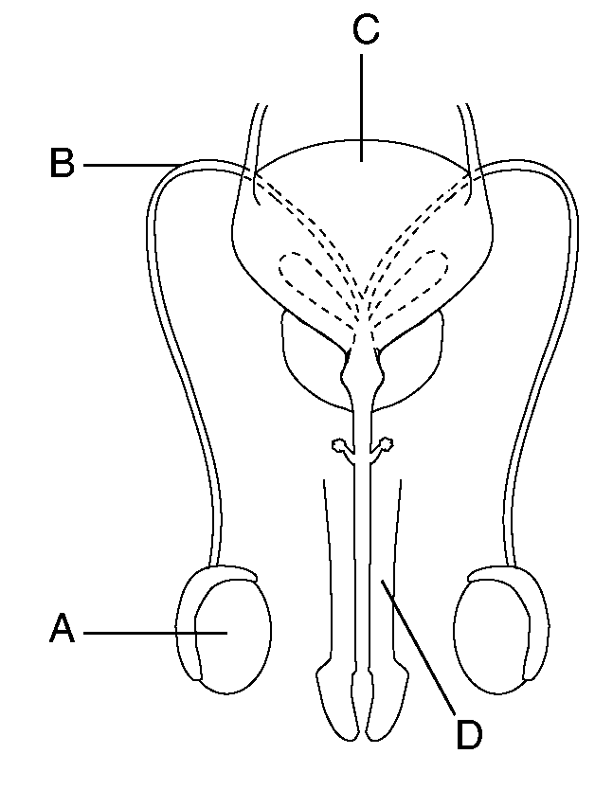**Word Bank**: testes meiosis store egg fluid energy smaller life sperm

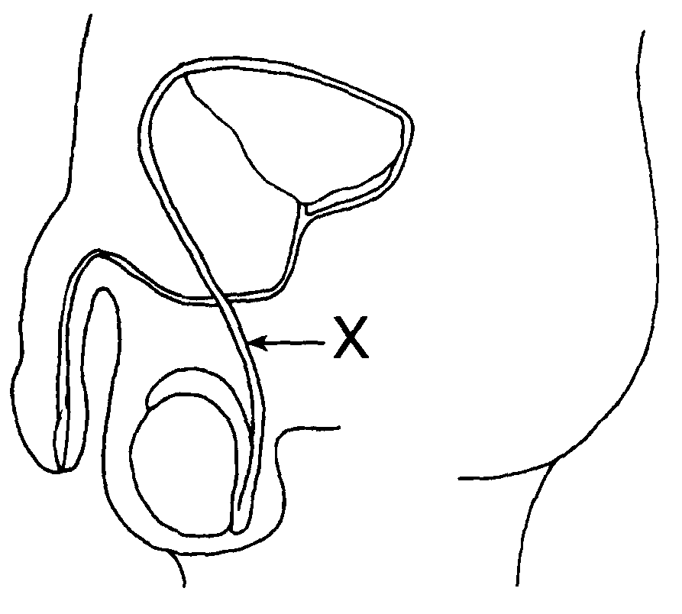

1. **Female Reproductive System**
   1. ________________ produce eggs.
      1. Eggs are haploid cells made by _______________.
      2. Females are born with all eggs they will ever ____________.
         * An egg is not fully developed until _________________.
         * Females are born with ___________ of eggs, enough for several lifetimes.
      3. Eggs are largest _________ in the body.
      4. Eggs do not _____________on their own.
      5. Contain 23 chromosomes and all cell parts (mitochondria, ribosomes, etc.) that the offspring will need to _________ and develop.
   2. The ___________ cycle lasts 28 days (on average)
      1. Ovulation – _____________ of an egg (typically 1 per cycle)
      2. Menstruation – ____________ of the uterine wall if fertilization doesn’t occur
      3. If pregnancy occurs, the menstrual cycle will temporarily __________.
   3. The _______________________________ carries the egg to the uterus.
   4. The ______________ is the womb where the baby will develop.
   5. The vagina is the ___________ canal where the baby will leave the body.

**Word Bank**: millions need meiosis ovulation ovaries uterus release

fallopian-tubes move cells grow menstrual shedding

stop birth

1. **Development**
   1. Fertilization occurs in the _____________________________.
      1. A fertilized egg is called a ________________.
      2. 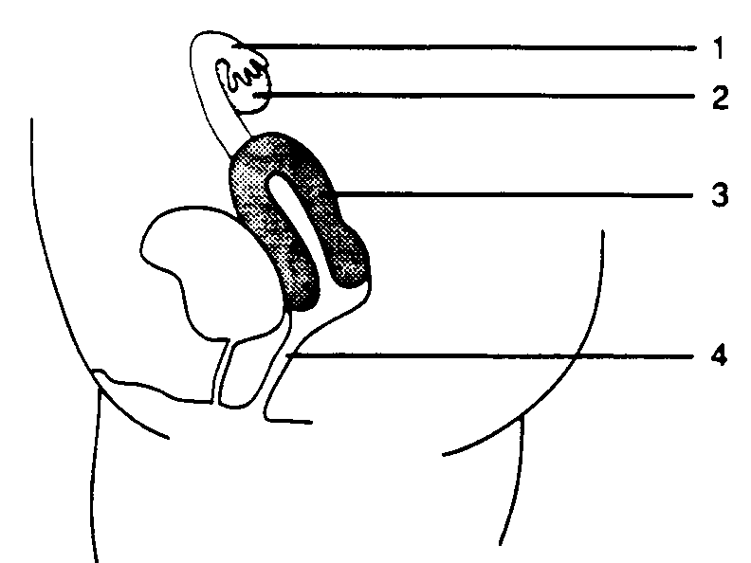Fertilization _______________ the complete set of chromosomes, so the zygote is diploid (23 from the egg + 23 from the sperm = ______).
   2. A zygote _________ in the following order:
      1. Cleavage – A form of _________________; cells divide but do not differentiate
      2. Differentiation – Cells begin to form into tissues and ______________.
      3. ______________
      4. ______________– most major organs are formed (but not completed)
         * Continues to grow through cell _____________ (mitosis)
   3. The__________________ transfers nutrients and oxygen from the mother’s blood into the blood of the fetus through the process of ____________________.
      1. The _________ of the mother and fetus do not mix.
      2. The fetus is attached to the placenta by the ______________________.
      3. Waste produced by the fetus is also __________ by the placenta.
         * Waste (CO2, urea, salts) *___________* from placenta into mother’s blood.
         * Since the fetus does not eat solid food, it does not have to eliminate __________.
   4. The child is vulnerable to alcohol, drugs, etc. because organs and systems are still ___________.

**Word Bank**: restores fallopian-tube 46 zygote mitosis embryo fetus placenta organs diffusion umbilical-cord division blood removed *diffuse* feces developing born correct process

**Late Development** – The fetus pictured here is nearly ready to be _______. Note the umbilical cord, placenta and amniotic sac.

**Fertilization** restores the ______number of chromosomes.

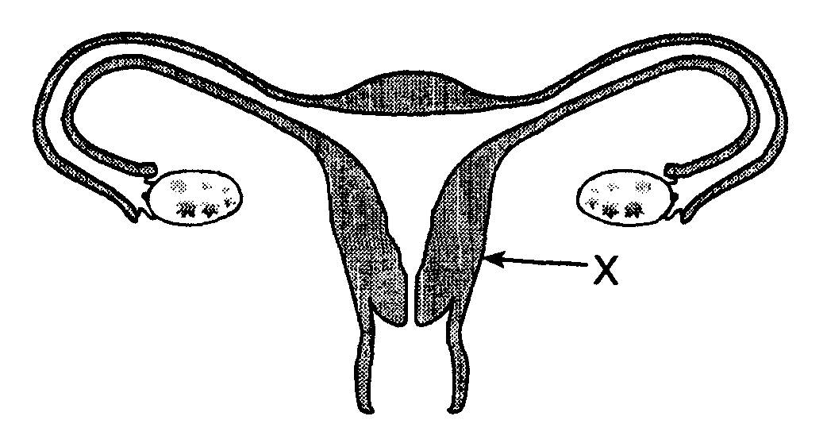

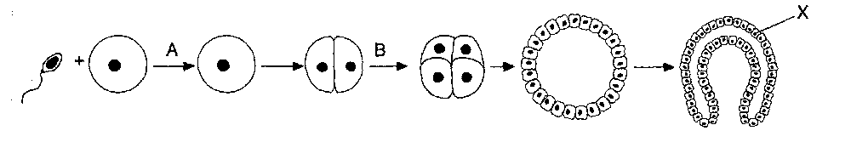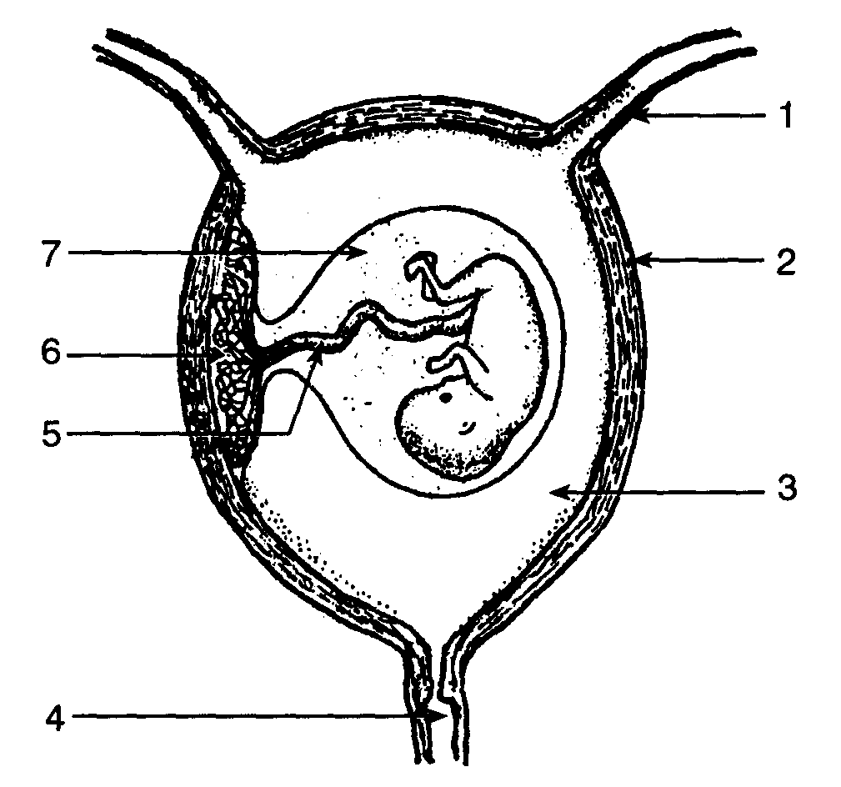

**Early development –** Fertilization (A) forms a single celled **zygote** which then begins the process of **cleavage (B)** which will eventually create a layered ball of cells that will form the embryo.

**Topic Six: Genetics**

1. **Chromosomes:**
   1. Humans have ______ chromosomes, or ______ homologous pairs.
      1. **Homologous:** Chromosomes with the _______ genes, size and shape.
   2. **Chromosome pairs** carry genes for the same _______.
      1. Most organisms have ________ genes for each trait - 1 from each parent, 1 on each member of the homologous pair.
   3. **Sex chromosomes –** In humans, females are ______ and males are ______.
      1. The Y chromosome is much _____________ than the X, so it is missing many genes. This means many genes on the X chromosome do not have a “_____” so:
         * If a male has a recessive trait on the X chromosome, the Y chromosome will not be able to “_______” it with a dominant gene, so...
         * This makes ________ more likely to have some traits (like color blindness). These are called **sex _________ traits.**
   4. **Common mistake**:“Humans have 23 _____________ (or 46 pairs of chromosomes, or some other incorrect number).”

*These numbers are often confused. You must memorize them correctly.*

**Word Bank**

46 same traits XY smaller hide partner 23 linkedtwo XX males chromosomes

1. **Chromosomes and Genes**
   1. Each chromosome has hundreds or thousands of ____________.
   2. **Each gene codes for a particular __________**.
      1. **Common mistake:** “Genes/DNA are made from protein.”

*Genes carry the instructions to make protein. The genes themselves are made from _____________.*

* + 1. While genes determine our traits, **the ________ can affect expression of genes.**

**Word Bank**: genesproteinnucleic-acidsenvironment

1. 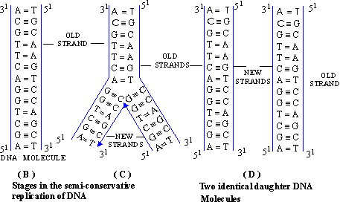**DNA**
   1. DNA is the chemical that makes up your ___________ and chromosomes.
      1. Analogy: If your genes and chromosomes are the “instruction manual” for your body, DNA would be the paper it is __________ on.
   2. The shape of a DNA molecule is a____________, which resembles a twisted ladder.
   3. The shape of DNA allows it to ___________________ (copy) itself almost perfectly.
   4. DNA is made of 4 bases: **____________________**.
      1. The DNA to DNA base pairs are: _________ and __________
         * The DNA to RNA base pairs are __________ and ____________

**Word Bank**

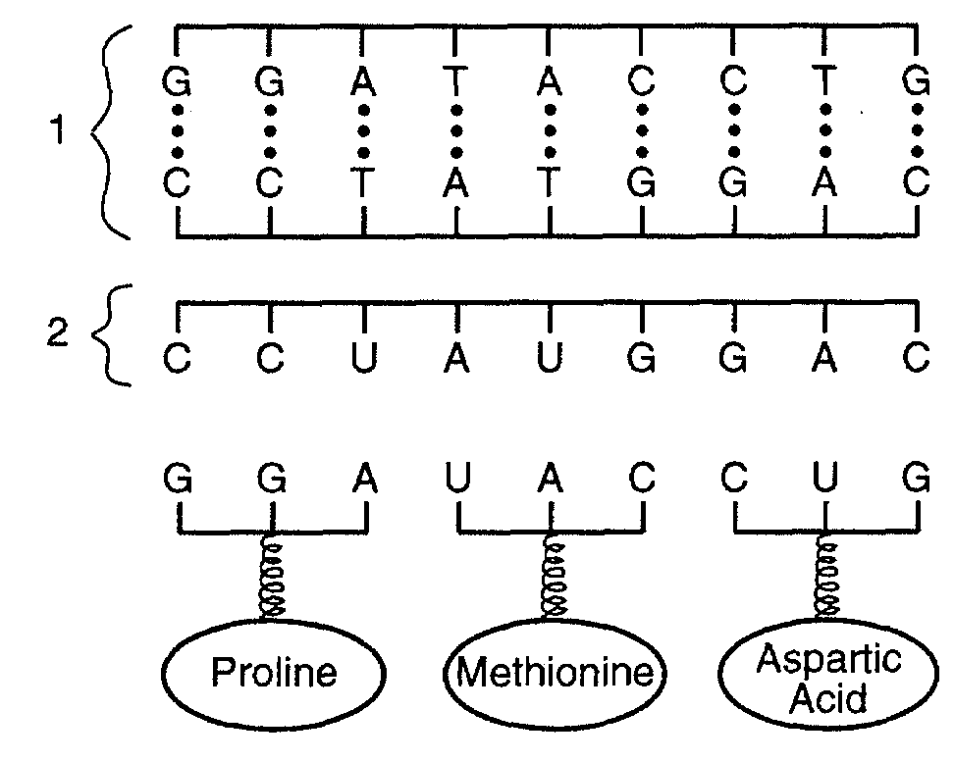C-G double-helix A-T genes A-U replicate A-T-C-G C-G printed

1. **Protein Synthesis**: This is how genes ___________ your body:
   1. A **__________** is a sequence of **amino-acid bases** in DNA**.**
      * + Each codon represents a specific **amino acid**.
        + ______________________ assemble amino acids in the same order that they are listed in the DNA codons.
        + The amino acids will make a __________________.
        + The _________ of the amino acids (determined by the DNA sequence) determines the shape of the protein.
        + The shape of a protein _____________ its function.
        + Therefore: The sequence of bases in DNA will determine the ____________________ of all the proteins in the body.
        + The proteins build and run the body.
   2. **______** carries the genetic code to **ribosomes**.

**Word Bank**

ribosomes function amino-acid protein control three RNA shape bases shape determines codon order

The order of DNA __________ in your genes determines the order of _____________________ in your proteins, which determines the protein’s ______________ and function.

**Therefore: How your body functions depends on the order of the bases in your genes!**

1. **Mutations:** Any _______ in an organism’s genetic material.
   1. Can only be passed on if they occur in ____________ cells (sperm or egg).
   2. Common **____________ agents** include radiation, chemicals and viruses.
      1. Mutagenic agent: Any __________ factor that causes mutations.
   3. **Gene mutations** may cause a change in a gene which can change the __________ of a ___________. This will have an _________ on the way the protein works (if it still works at all).
      1. Gene mutations are caused when DNA bases are in some way __________.
   4. **Chromosome mutations** are usually caused when a person _______ too many or too few chromosomes.
      1. Chromosome mutations affect many genes at once. Most are _________.
      2. **Down’s Syndrome**: Non lethal mutation, caused by inheritance of an ____ copy of chromosome 21. (Note – only chromosome 21 can cause Down Syndrome).

**Word Bank**

change shape environmental inherits effect protein reproductive changed mutagenic extra lethal

1. 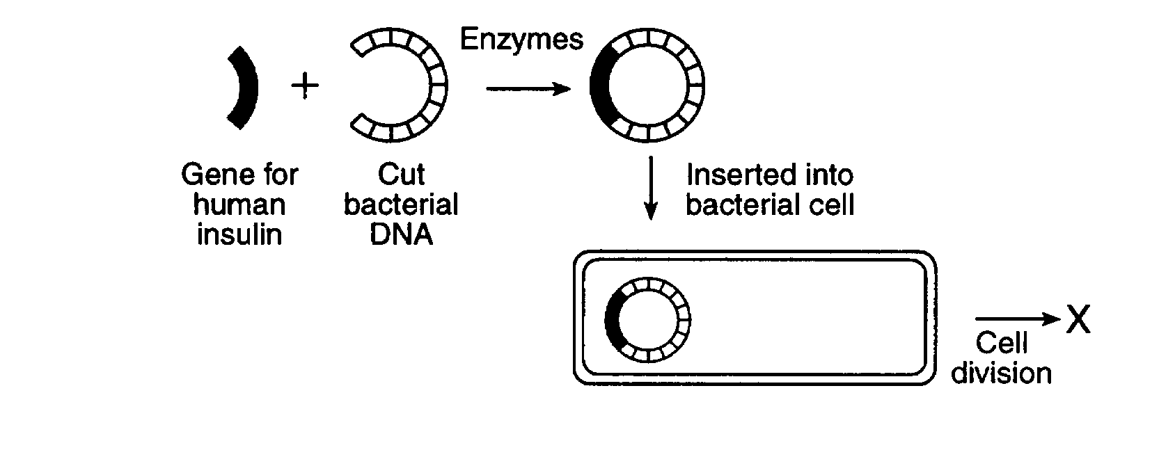**Genetic technology:**
   1. **Selective breeding**: Controls the breeding of animals or plants to produce offspring with ____________ traits.

Ex: Dogs are **selectively bred** for temperament and a variety of   
________ ___________ traits (coat type, color, size).

* 1. **Genetic engineering:** “_______” a gene from one organism and “pastes” it into the DNA of a new organism.
     1. ____________________are used to cut and paste the DNA segments.
     2. Organism that receives the new gene will begin to make the _______________, ___________________ or hormone coded for by that gene.

**Word Bank**

desirable protein cuts enzyme appearance restriction-enzymes

* + 1. The new protein/enzyme/hormone will be exactly the same as the one produced by the _________ organism.
    2. _______________are often used because they are simple and reproduce quickly.
    3. The example of gene splicing you MUST know:
       - **Bacteria have been engineered to make ________________ for diabetics.**
       - **Bacteria have been engineered to make ___________________________.**
       - In both cases the ___________ hormones are safe to use because they are identical to normal human hormones.

**Word Bank**

original engineered bacteria insulin growth-hormone

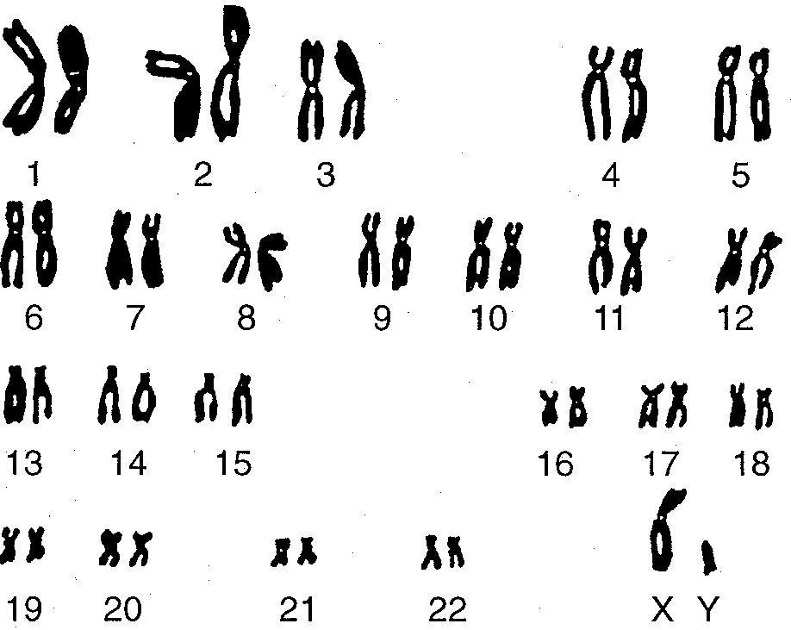

* 1. New technologies (**karyotyping, DNA fingerprinting**) are making it easier to diagnose and treat genetic __________, though we cannot yet cure them.
     1. **________________:** A photograph of an organism’s chromosomes.
        + Can determine if a person has a chromosome ____ such as Down Syndrome.
     2. **DNA ________________**, or gel electrophoresis, creates banded patterns based on a person’s DNA base sequence.
        + Each fingerprint is unique, so it can be used to __________ people.
        + Fingerprints of relatives are similar to each other, so can be used to determine genetic __________ between two people, or even two groups of organisms.
  2. Genetic research has posed many **________** problems (ie right and wrong) that science alone cannot answer.
     1. Ethics: Study of what is __________ right or wrong.

**A karyotype** shows all 23 pairs of human chromosomes. Note the last pair identifies this as a male.

**Word Bank**

disease karyotype disorder fingerprinting identify relationships morally ethical **Topic Seven: Evolution**

1. **Evolution**: _____________________________________________________________________
2. **Modern Theory of Evolution:**
   1. **Charles Darwin:**
      1. Was not the first to think of __________, but he did figure out how it works (mostly).
      2. Darwin didn’t know about __________, so he couldn’t know about mutations.
   2. The ________ theory (which combines Darwin’s ideas with genetics and other new ideas) contains the following ideas:
      1. Earth is old (4.55 billion years) and is constantly ______________.
      2. As the environment changes, evolution causes species to _____ to their environment.
      3. **______________________________________** is the **mechanism** that causes species to change.
      4. **Common Descent:** Modern species evolved from _______, different species and share a **_________ ancestor**.
      5. Species that can not adapt become _____________________.
      6. New traits arise in a species from __________ and ______________________.

**Word Bank**

genes changing common evolution adapt

modern earlier natural-selection extinct mutations

gene-recombination

1. **Environment and Evolution**: Species usually ___________ when the environment changes.
   1. Changes need to be long term – species do not evolve because of changes in the _______.
   2. Changes can include:
      1. Climate change
      2. Change in temp
      3. Change in _________ availability
      4. Change in _________ availability
      5. Introduction of _______ species (new food, new predator)
      6. Species may be moved to a new ______ (accidentally taken to an island for example)
   3. Environmental change **DOES NOT** **CAUSE** ____________ to occur. A temperature or climate change does not itself force a species to change its ___________ characteristics.
      1. If this were the case, then all ________ would be able to __________ to the new environment, and _________ would be a very rare event.

**Word Bank**

season evolve inherited location evolution water food adapt new species extinction

1. **Natural Selection:** The basic steps in natural selection are:
   1. __________________________________: Members of a species are different from each other due to ___________ and sexual reproduction.
      1. No variation = no evolution or natural selection, as there is nothing to “______.”
         * Species with no variation are usually the first to _____ when the environment changes.
   2. ___________________________________: Too many offspring are produced.
   3. ______________________________: Offspring must struggle to survive and reproduce.

**Word Bank**

die mutations select variation overproduction competition

* 1. ______________________________:
     1. Offspring who inherited “fit” traits are, on average, better able to get _________, escape from predators and find mates.
     2. Offspring with “unfit” traits will have more difficulty ______ and finding mates.
     3. **Fitness:** A _________ of how well a trait helps an organism to survive and reproduce in its environment. Note that there is no absolute rule for fitness – what is fit in one environment may be _______ in another.
     4. **Note:** This “selection” is not a conscious act – no one is “choosing” who survives and who doesn’t. It is the result of the conditions of the organism’s ________________.

**Word Bank**

unfit survival-of-the-fittest environment surviving resources measure

* 1. ________________________________:
     1. More ____ organisms reproduce and pass on their genes than unfit organisms.
     2. On average, the next generation will have more traits from the “fit” parents than the _______ ones.
     3. NOTE: Traits are still inherited ___________. Individuals offspring of “fit” parents can still _________ “unfit” traits (though it will be unlikely to survive and reproduce). It is only by looking at the ENTIRE population that you will see the “fit” traits become more ______________.
  2. _____________________: Evolution does not happen overnight. It takes many generations of __________ selection to weed out the unfit traits.

**Word Bank**

reproduction randomly inherit repetition fit unfit common repetitive

**V. Speciation:** The process of making a new species from an ___________ one.

* 1. **_____________ Isolation**: A population is separated into 2 or more different habitats.
  2. **New _____________ and adaptation:** Each population adapts to its new environment in different ways. This results in physical and ___________ differences between the two populations.
  3. **Add time:** The longer two populations are _____________, the greater their differences will become.
  4. **________________ Isolation:** Eventually the populations change so much that they are unable to interbreed, even when brought together.
     1. **Once two populations can no longer ____________ together, they are considered new species.**

**Word Bank**

genetic reproductivebreedapart geographicvariationexisting

1. **Classification**- Organisms are classified based on their _____________ relationship.
   1. ________________ are large groups of related organisms (fungi, bacteria, protists, animals, plants).
   2. A **species** is able to successfully ______________ amongst its members.
      1. Note that this is not a perfect definition – Lions and tigers can breed together, as can dogs and wolves. Because evolution is a constantly ongoing and a ___________ process, there are many, many examples in which the lines between ______________ are blurry (see Ring Species)
   3. Branching _________ diagrams (cladograms) are often used to show evolutionary relationships.

**Word Bank**

reproduce kingdoms tree evolutionary species gradual relationships

1. **Evidence:** Evidence in _____________ of evolution comes from many fields:
   1. **___________** **record** preserves extinct species as well as transitional forms between different types of organisms.
   2. **Radiometric _____________** of rocks consistently confirm the age of the Earth and fossils
   3. Comparisons of the _____________ (physical structures), embryology (development), chemistry and genes of species confirm expected ____________.
   4. **Direct observation**: Humans have seen evolution occur both in _____________ and in the lab. Examples include:
      1. **Bacteria** evolving ____________ to antibiotics.
      2. **Insects** evolving resistance to ______________.
      3. Modeling natural selection with ____________ breeding to alter a species’ traits.
      4. __________ examples of speciation

**Word Bank**

anatomy support relationships datingfossil

nature resistance pesticides selective observed

1. **Common Mistakes**
   1. “Stronger organisms are more ______ than weak ones.”

*Evolutionary fitness is not __________ fitness. Fitness is determined by who is better _________ to survive in a particular environment and who can pass on their _______. Stronger is not always _________. There are many examples of species for whom it is better to be slow, ______, or stupid, than fast, strong or smart. It all depends on the _____________ you are in.*

* 1. “The organism evolved to live in its environment.”

*Individual organisms do not ___________. Only ___________ can evolve.*

* 1. “The organism could not adapt and it went extinct.”

*Individual organisms die; they cannot go _________. Only _______ can become extinct.*

**Word Bank**

adapted weak fit genes physical better

environment evolve populations extinct species

* 1. “The bacteria became resistant to antibiotics when they were exposed to them”

*To evolve, _________ must exist in a species BEFORE the ________ changes (pre-adaptation). Bacteria who did not already have a _________ to antibiotics would die when exposed to them, a Chihuahua who is left out in the cold will not grow _____, warm fur and a squirrel who plays in traffic will not evolve _______________ resistance.*

* 1. “Giraffes got long necks because they _________ them to eat leaves at the tops of trees.” *Species do not _______ traits because they need them - Life would be much better if we could! _________ necked giraffes were never given long necks any more than slower antelopes are given _________ when confronted by a predator. The reason there are no short necked giraffes (or slow antelope) is that they were out ________ by members of their species with more ______ traits. Better answers are*
     + - “Giraffes evolved long necks because the ones with longer necks were better __________ to get food than short neck giraffes.”
       - “Giraffes evolved long necks because more short necked giraffes _______, and more long neck giraffes lived and _____________.”

**Word Bank**

long environment variations resistance automobile

speed needed evolve short competed

reproduced fit adapted died

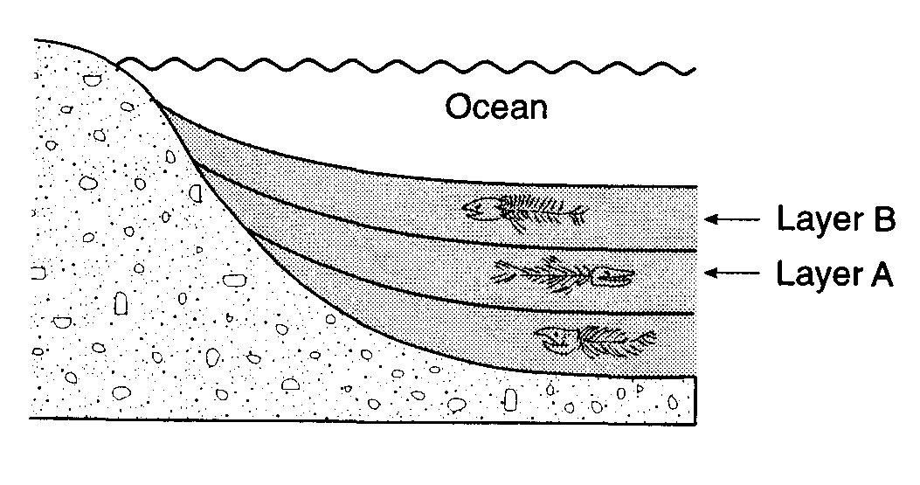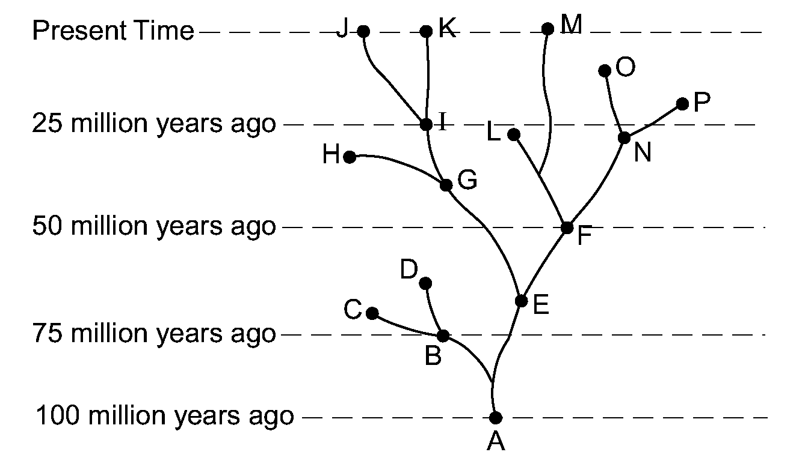

1. 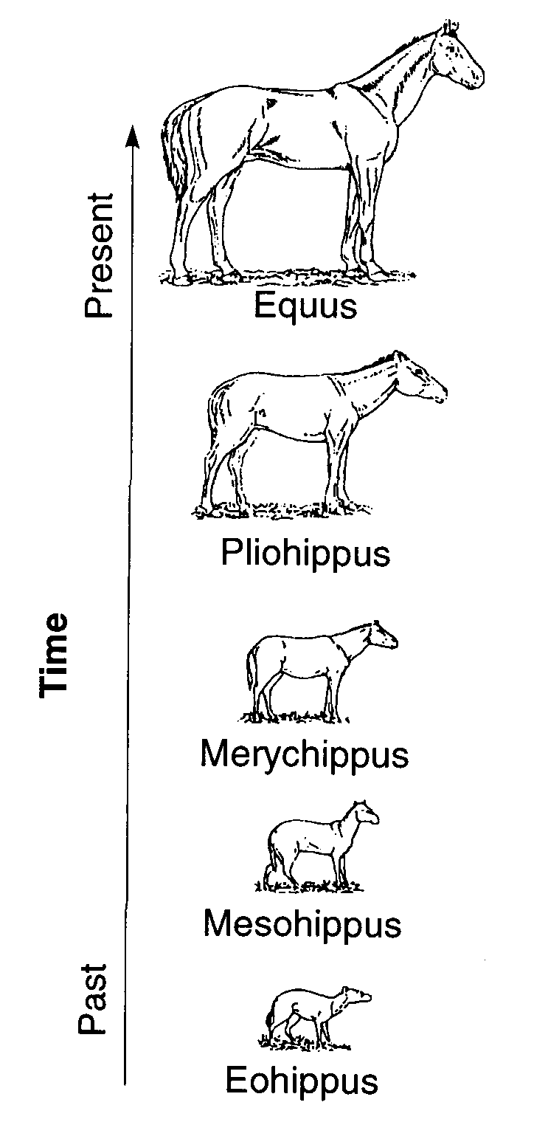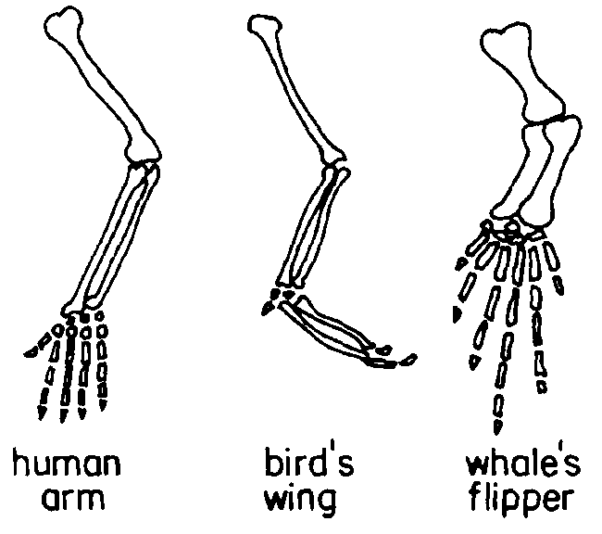

Deeper fossils are typically older than those above them.

**Transitional forms** for many species can be found in the fossil record. This diagram shows the evolution of the modern horse from a small, many-toed ancestor.

**Homologous Structures** reveal that the same body parts can be modified to perform different functions.

**Evolutionary trees** can show the relationship between living and extinct species.

**Topic Eight: Ecology**

**Ecology:** Study of organisms and their ___________________.

* 1. **Habitat:** Where an organism ___________.
  2. **Niche:** What an organism ________ and how it gets nutrients.
     1. **Two species in an ecosystem trying to fill the same niche will create** _____________, which usually results in only one species ___________ a niche at any one time. Organisms with similar needs will often ___________ resources to reduce competition (ex: birds eat insects during the day, bats eat _________ at night).

**Word Bank**

competition does divide lives insects occupying environment

* 1. **How organisms _________ with each other:**
     1. Competition: occurs when two or more organisms _______ the same resource.

Ex: A squirrel and a chipmunk __________ for food.

* + 1. Feeding: One organism _______ on another.
       - __________ – An autotroph; organisms that makes its own nutrients from simple substances.
       - Consumer – A ___________; may be an herbivore, carnivore, omnivore or decomposer.
    2. ___________: A close relationship between two organisms in which at least one benefits.
       - Can include 2 organisms working together for ________ benefit (bee and flower) or 1 organism harming another (parasite-host).

**Word Bank**

feeds mutual interact compete symbiosis producer need heterotroph

1. **Organization**
   1. Abiotic Factors are _________ things.
   2. Biotic Factors are ________ things.
   3. Levels of organization:

Population – one ______ in an area.

Community – _____ species in an area.

Ecosystem – All species and ________ factors in an area.

Biome – Similar _________ (desserts, rain forests, etc.)

Biosphere – All of _________ecosystems.

**Word Bank**

species living ecosystems all abiotic non-living Earth’s

1. **Populations**: A given area can only supply enough _____ for a limited number of organisms.
   1. Carrying capacity: ________ population that an ecosystem can support.
   2. Limiting factors: Anything which limits the ______ of a population, including: food, water, sunlight, soil, predators and disease.
   3. ________________: When a population exceeds the carrying capacity. Usually results in a large number of organisms dying off until a new balance is __________. This fluctuation in population is an example of dynamic ____________.



**Word Bank**

size resources equilibrium largest reached overpopulation

1. **Energy in an Ecosystem**
   1. Sunlight provides all _________ for life on Earth.
   2. Sun’s energy is stored in the chemical bonds of food through the process of __________.
   3. Food chain – Shows 1 way that energy can “______” through an ecosystem.

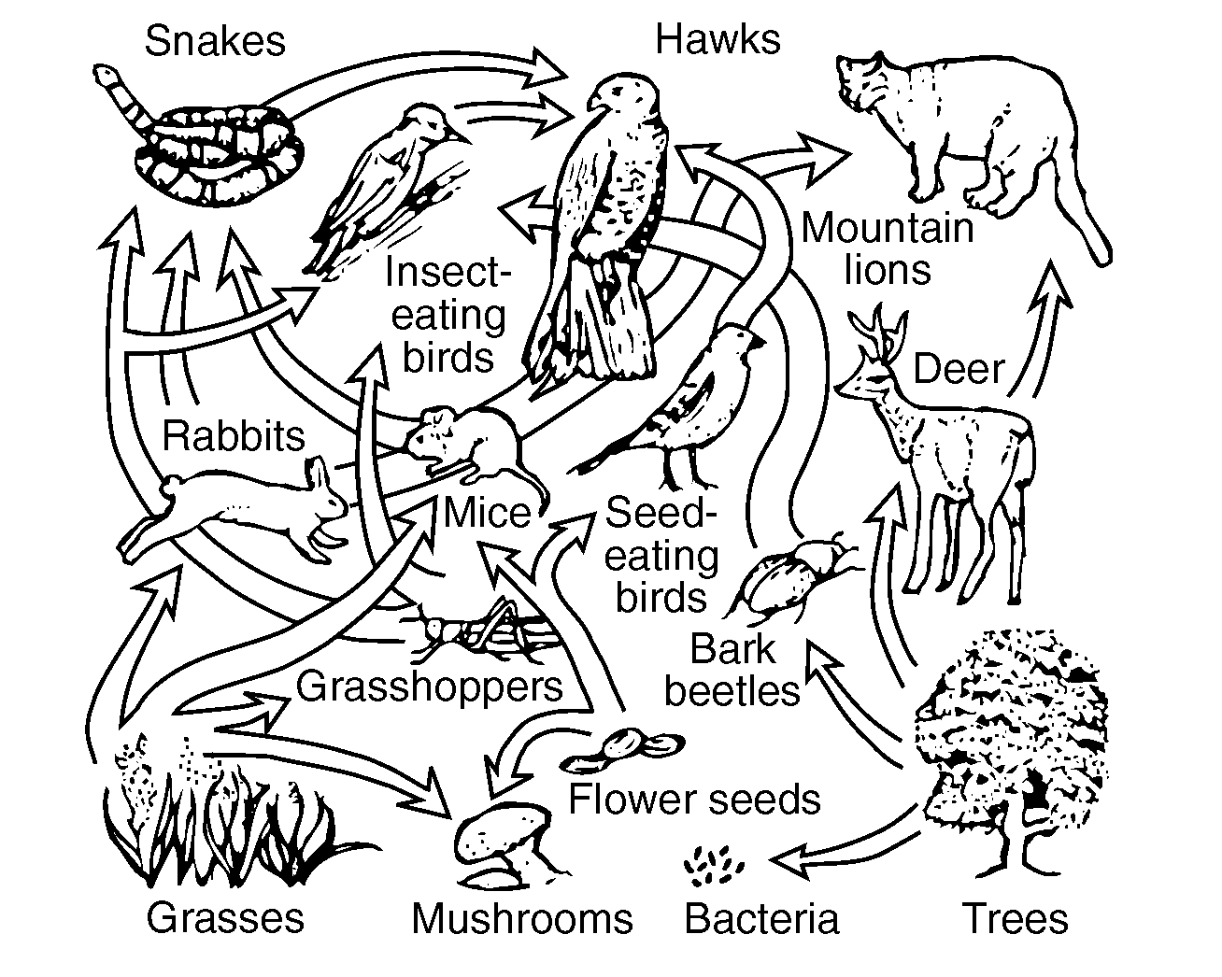

* 1. Food web – Shows many _________ pathways.

**Word Bank**

many energy flow photosynthesis

* 1. Energy pyramid: Shows that energy gets _______ with each step in a food chain
     1. Energy is lost because every organism uses some of the energy for it’s own life ____________. Only about 10% of energy is _______ from one step to the next.
     2. 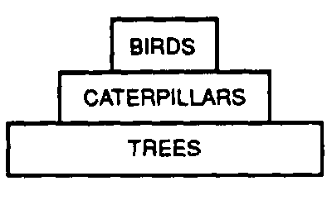This is why populations of ___________ are typically less than the populations of their prey.

**Word Bank**

processes predators lost passed

1. **Biodiversity** refers to the variety of _______ on earth.
   1. **___________ ecosystems** (those with many types of species) are more stable than ones that are not diverse.
   2. As habitats are lost and species become __________, biodiversity is reduced. This is considered to be bad because:
      1. Ecosystems with low diversity are less ________ than ecosystems with more diversity,
      2. Ecosystems with low diversity take longer to recover from environmental _________.
      3. Humans use organisms for many things such as ________ and medicine; by reducing _________ we are losing potentially valuable resources.

**Word Bank**

diverse life changes biodiversity food stable extinct

1. **Ecological Succession**: Process in which existing communities are gradually replaced by a series of ______ communities.
   1. The organisms in each ________ of succession change the environment, and allow new organisms to move in and replace them.
   2. **Climax Community**: _________ stage of succession.
      1. The climax community is determined by the _________ climate.
         * Ex: Kansas has very fertile soil, but not enough rain to support trees, so succession ____________ with grasses and shrubs.
   3. Any temporary ________ of a community will begin the process of succession all over again.
      * + Ex: If a forest fire _____ all the trees in an area, succession will eventually return the area back into a forest, but it much first pass through all the _________ stages.

**Word Bank**

kills local necessary disruption stops stage new final

1. **Human Impact**: Human __________ can have both a negative or positive impact on the environment.
   1. **The primary reason humans have a _________ impact on the environment is because the human population is growing, which places a greater demand on _________ such as food, water and space.**
   2. **There are no easy solutions to any ecological ___________. Every _________ can have negative consequences. Choosing the “right” actions requires weighing the __________ with the risks.**
   3. ________ actions that generally have a negative impact on the environment include:
      1. Development/__________
      2. Pollution
      3. Farming
      4. ____________/overgrazing
      5. Clear cutting/____________
      6. Introduction of _________ species

**Word Bank**

negativeindustrialization solutionresourcesdeforestation actions benefitsproblem human overhunting foreign

* 1. **Actions being taken by humans to reduce or repair ___________ to the environment include:**
     1. Recycling ___________
     2. Conserving __________ resources
     3. Using _________ resources (ex: solar over fossil fuels)
     4. ___________ of habitats and endangered species
     5. Use of biological controls instead of pesticides and ____________
     6. Farming native plants (ex: cocoa in the rainforest)
     7. Planting __________ to replace those cut down.
     8. Rotating crops or planting cover crops to reduce soil ____________.
     9. Passing _______ to control pollution, land management, hunting, fishing, etc.

**Word Bank**

available trees loss damage protection wastes cleaner herbicides laws

1. **Specific Environmental Problems:**
   1. Acid rain
      1. **Cause**: Burning fossil fuels which emit ________ and SO2 which react with water to form acid.
      2. **Negative effect**: ___________ of soil and water which kills plants and wildlife.
      3. **What can be done**: Reduce use of ______ fuels. Use air scrubbers to reduce __________. Use ________ to neutralize acid. ______ have a pH level between 0 and near 7. Bases have a pH level from near 8 to 14. A pH of 7 is _________.

**Word Bank** acidification fossil NO2  acids emissions buffers neutral bases

* 1. Depletion of ozone layer
     1. **Cause**: Using CFC’s in coolants and _______ sprays.
     2. **Negative effect**: Increases skin ________.
     3. **What can be done**: _______ using CFCs.
  2. Industrialization
     1. **Cause**: Change from agriculture to factory or ______________.
     2. **Negative effect**: Increased __________. Uses more land and __________.
     3. **What can be done**: _________ to regulate pollution, recycling, set aside land for preservation and state and national ____________.

**Word Bank**

stop resources aerosol parks pollution industry cancer laws

* 1. Loss of habitat (ex: ________________)
     1. **Cause**: Industrialization, farming and housing
     2. **Negative effect**: Species lose habitat which is a loss of biodiversity and possible ______________. This may disrupt the food chain and ecosystems.
     3. **What can be done**: ____________ the development of industries. Preserve the _________ and national parks.
  2. Loss of bio diversity
     1. **Cause**: __________ loss, overhunting/harvesting, pollution, climate change and introduction of new species.
     2. **Negative effect**: Extinction. Ecosystems become less __________. Potential loss of valuable ____________.
     3. **What can be done**: Regulate hunting / fishing / _________. Endangered species act ________ endangered species. Breeding programs to increase ___________.

**Word Bank:** habitat resources stable protects population extinction regulate land collecting deforestation

* 1. Global warming
     1. **Cause**: Greenhouse gas _________ (CO2) from fossil fuels.
     2. **Negative effect**: May lead to habitat loss, loss of biodiversity, extinction and climate ______________.
     3. **What can be done**: Reduce emissions. Use _________ fuels and alternative energy. __________ energy. Plant trees. Use new __________________.
  2. Introduced ____________
     1. **Cause**: _______ species brought to new ecosystems by human travel and trade.
     2. **Negative effect**: Alien species can out compete _________ species. Reduces biodiversity.
     3. **What can be done**: Use biological controls to __________ species or limit population. Control trade and sale of __________ plants and animals. Screen cargo ships, planes, etc. for “____________.”

**Word Bank:** technology emissions conserve change species native exotic cleaner remove foreign hitchhikers

**Topic Nine: Experiments and Graphing**

1. **Terms:**
   1. **___________:** What is seen or measured.
   2. **___________:**  A conclusion based on observation or evidence.
   3. **Hypothesis:** A _________based on available evidence. A good hypothesis states both cause and ______.
      1. A correct hypothesis can be ______and **falsified** (proven incorrect) using an **experiment**.
      2. The easiest way to write a correct hypothesis is as an **“____________”** statement. (ex: IfI give patients this pill, then they will not get sick.)
   4. **Theory:** An ___________of natural events that is supported by strong evidence.
      1. Theories tie together many scientific facts, hypotheses and ___________.
      2. **Common Mistake:** “Theories are things that are ________, or are not proven.”

*This is an incorrect use of the word “theory” in a scientific _________. A scientific theory is* ***not*** *a simple ________or conjecture, and* ***is*** *strongly supported by________.*

**Word Bank**

effect explanation inference tested evidence if-then-because prediction context observation opinions guess laws

**Example of a Controlled Experiment:**

**_____________:**  
**If** people chew gum **then**, it will improve their memory **because** of the ingredients . . .

______________**variable:**

Chewing gum – some people will chew gum, some will not.

**Dependent variable**

Memory – ______groups should have their memory checked both before and after the experiment to see if it was improved.

______________**Group**

Group that chews gum.

______________**Group**

Doesn’t chew gum (remember – the control group never receives the new treatment)

**Constants**Should be the _________for both groups:

People in each group should be of similar health with ____________memory, with similar mixes of sexes, ages, and ethnicities. Each group should also be __________in the same way.

___________**collected**

You should test people’s memories both before and _________the experiment.

**Word Bank**: similar data tested experimental after same independent control all hypothesis

1. _____________**Experiments:**  Compares the results of an experiment between one or more experimental groups with a “_________” group.
   1. **Experimental group:**  Group being ___________or receiving treatment.
   2. ___________**group:**  “Normal” group. Should be _________to experimental group in every way except *one*: it does not receive the new treatment.
   3. **Placebo:** A sugar pill or other “fake” treatment ________to the control group. Usually only needed when using human subjects.
   4. ___________**Variable:** ____________that is being tested (ex: new drug, new fertilizer).
      1. The “If” part of an “If-then” hypothesis.
      2. The independent variable is always plotted on the _____axis.
   5. **Dependent Variable:** Variable that is ___________at the end of an experiment; the results.
      1. The “then” part of an “If-then” __________.
      2. The dependent variable is always plotted on the ______ axis.

**Word Bank**

measured hypothesis tested independent control X variable identical normal controlled Y given

1. **Graphs and Data Tables**
   1. ___________are used to organize data which will be plotted in a graph.
      1. First column in the table is for the ___________**variable**.
      2. __________column is another for the **dependent variable.**
      3. Each column should be _________, and include units of measurement.
      4. Data in the table must be __________in ascending or descending

order.

* 1. Both the x and y axis of the graph must be ________or titled. These labels are typically the _________ones used in the data table. Once again units of __________must be written with the title.
     1. The **independent variable** is always plotted on the ___________.
     2. The **dependent variable** is always plotted on the ____________.

**Word Bank**

labeled measurement x-axis same second arranged independent titled data-tables y-axis

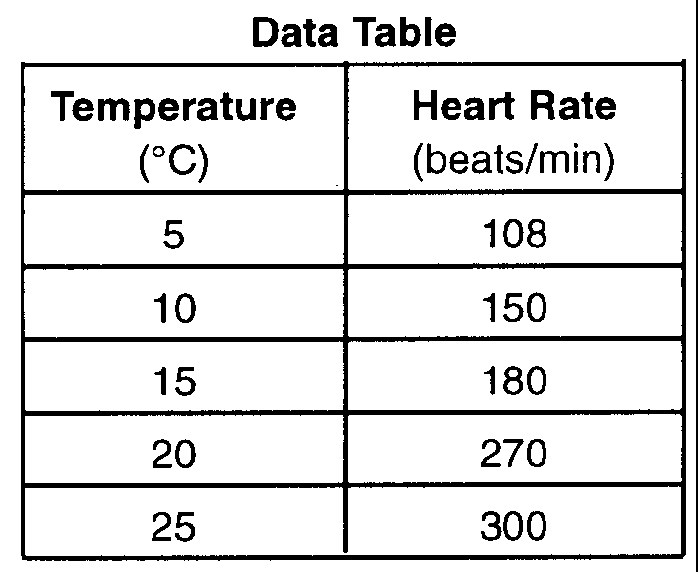

* 1. The x and y axis must be ______________.
     1. **These numbers must increase by a uniform _____________** (that is you must count by 1’s, 2’s, 5’s, 10’s, etc).
     2. **Your numerical scales should take up most of the** ________. _____________it all into the bottom corner makes the graph impossible to read and no credit will be given.
     3. The **numbers must line up with the** ____**lines** of the graph, not with spaces between them.
     4. **You do not need to start numbering your axis with** __________.
  2. To date, all graphs drawn on the LE Regents have been ________**graphs**. Any student who draws a bar graph instead of a line graph will be ________credit for this part of the test.
  3. All points plotted on your graph must be **surrounded by a** _________(or sometimes a square or triangle, depending on the directions).

**Word Bank**

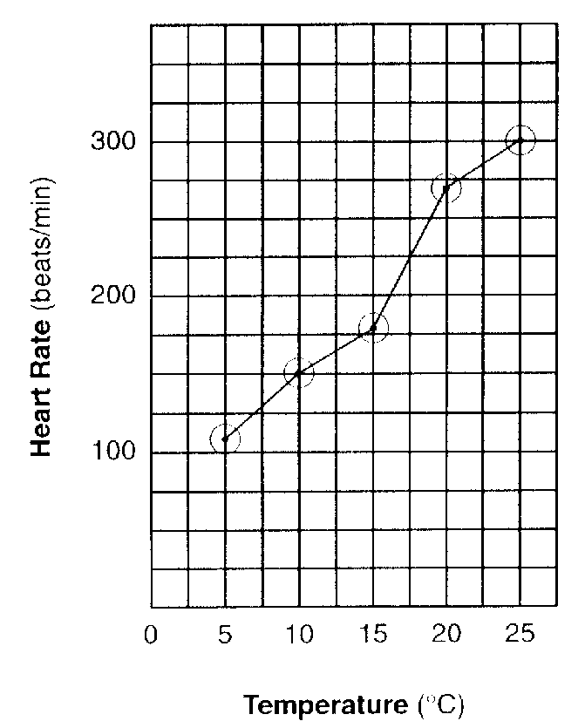line 0 axes squeezing denied circle grid numbered increment

**Characteristics of a good experiment:**

* 1. **Can be** ___________**the same way and get the same results.**
  2. **Have** _______**sample size/many test subjects.**
  3. **Are performed over** _________**periods of time.**
  4. **Test only one** ___________**variable.** All other characteristics of the _________groups should be the same.
  5. **Are** _________**reviewed –** examined by other scientists to determine its accuracy.
  6. **Must test the hypothesis and show** __________**it is wrong or right**.
  7. **Is objective –** the experiment and conclusion are fair and ___________. Fact and opinion are not _____________.
  8. The experiment follows established ____________and **legal** standards.

**Word Bank**

mixed whether tested large longer peer independent unbiased repeated ethical

**Topic Ten: The State Labs (Part D)**

1. **Making Connections (aka The Clothespin Lab)**
   1. **Part A**
      1. **What you did:** measured how exercise affected ___________ rate.
      2. **What you learned:** exercise __________ pulse rate.
   2. **Part A2**
      1. **What you did:** Squeezed a clothespin for 1 minute, then _________ it again for another minute
      2. **What you learned:**
         * If you squeezed more in the second round, it may have been because your finger muscles were “warmed up” from increased ___________.
         * If you squeezed less the second round, it may have been because your finger muscles were ______________.
   3. **Part B**
      1. **What you did:** Designed an experiment to test how exercise __________ squeezing a clothespin.
      2. **What you learned:** How to _________ an experiment (see pages 3-5).

**Word Bank**

increases affects design fatigued pulse squeezed circulation



1. **Relationships and Biodiversity (*Botana curus* lab)**
   1. **What you did:** Compared 4 species of plants, based on _________ (physical) and ____________ (chemical and genetic) traits.
   2. **What you learned:**
      1. Species that are related __________ similar traits.
      2. Different techniques (such as **gel electrophoresis** and **paper chromatography**) can be used to determine ___________ between organisms.
      3. ________________ species should be protected because they may offer benefits to humans.

**Word Bank**

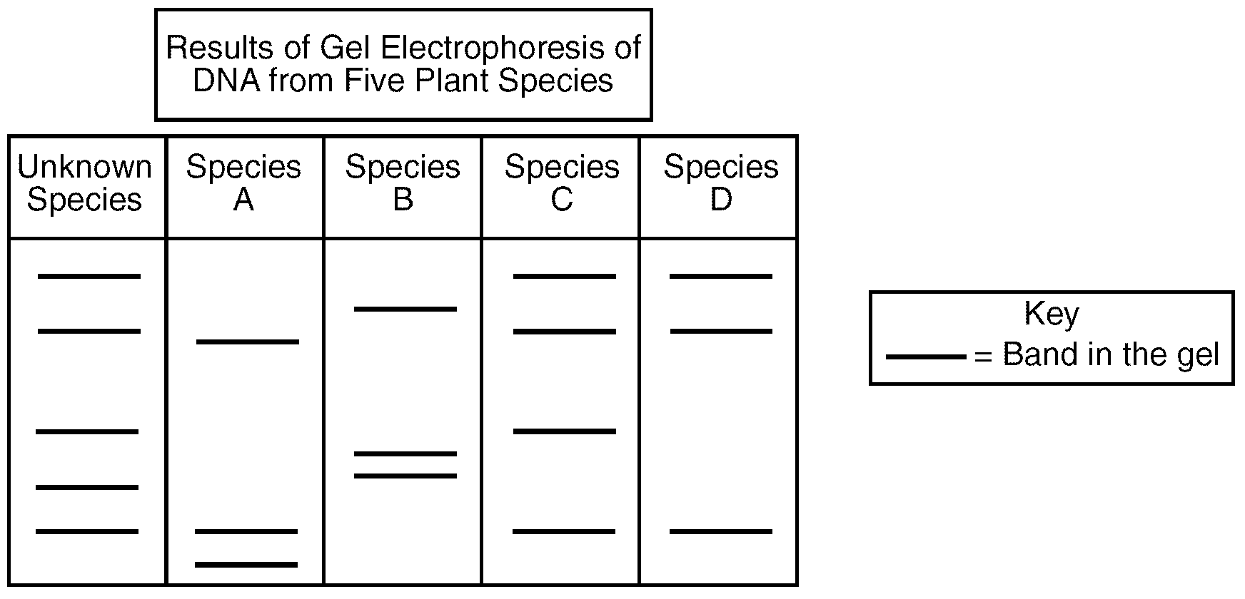molecular endangered relationships share structural

**Gel ___________________ –** A technique used to show how species are related to one another.

**Restriction enzymes** cut DNA into _____________, which are placed into a well in a gel plate.

An **electric current** carries the DNA fragments through the gel, separating them according to ______ (smaller pieces of DNA are carried farther from the well than larger pieces). **This creates a pattern of ___________ which is unique for every organism.**

Related organisms will show similar banding patterns because their DNA have similar base sequences.

**Word Bank**

fragments size bandssimilar electrophoresis

1. 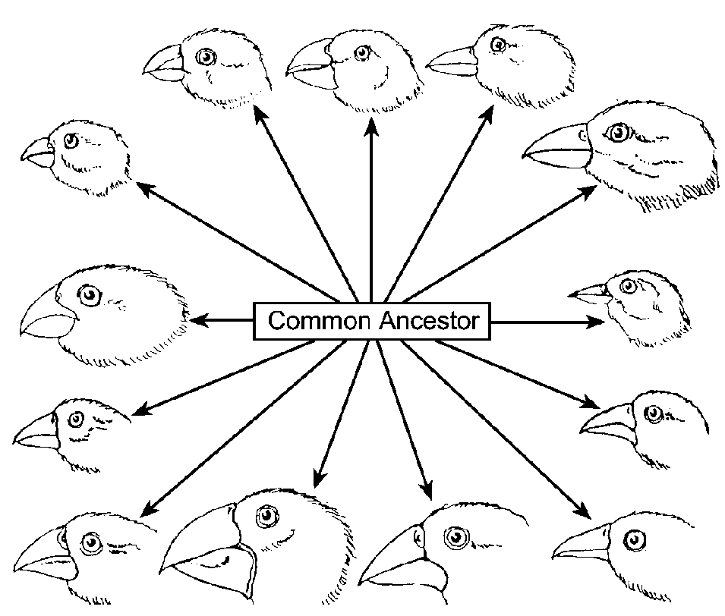**Beaks of Finches**
   1. **What you did:** Played different finch species ____________ for food.
   2. **What you learned:** Different environmental conditions (food) ________ different species of finch, allowing some to ___________ and reproduce, but not others.

**Word Bank**

favored survive competing

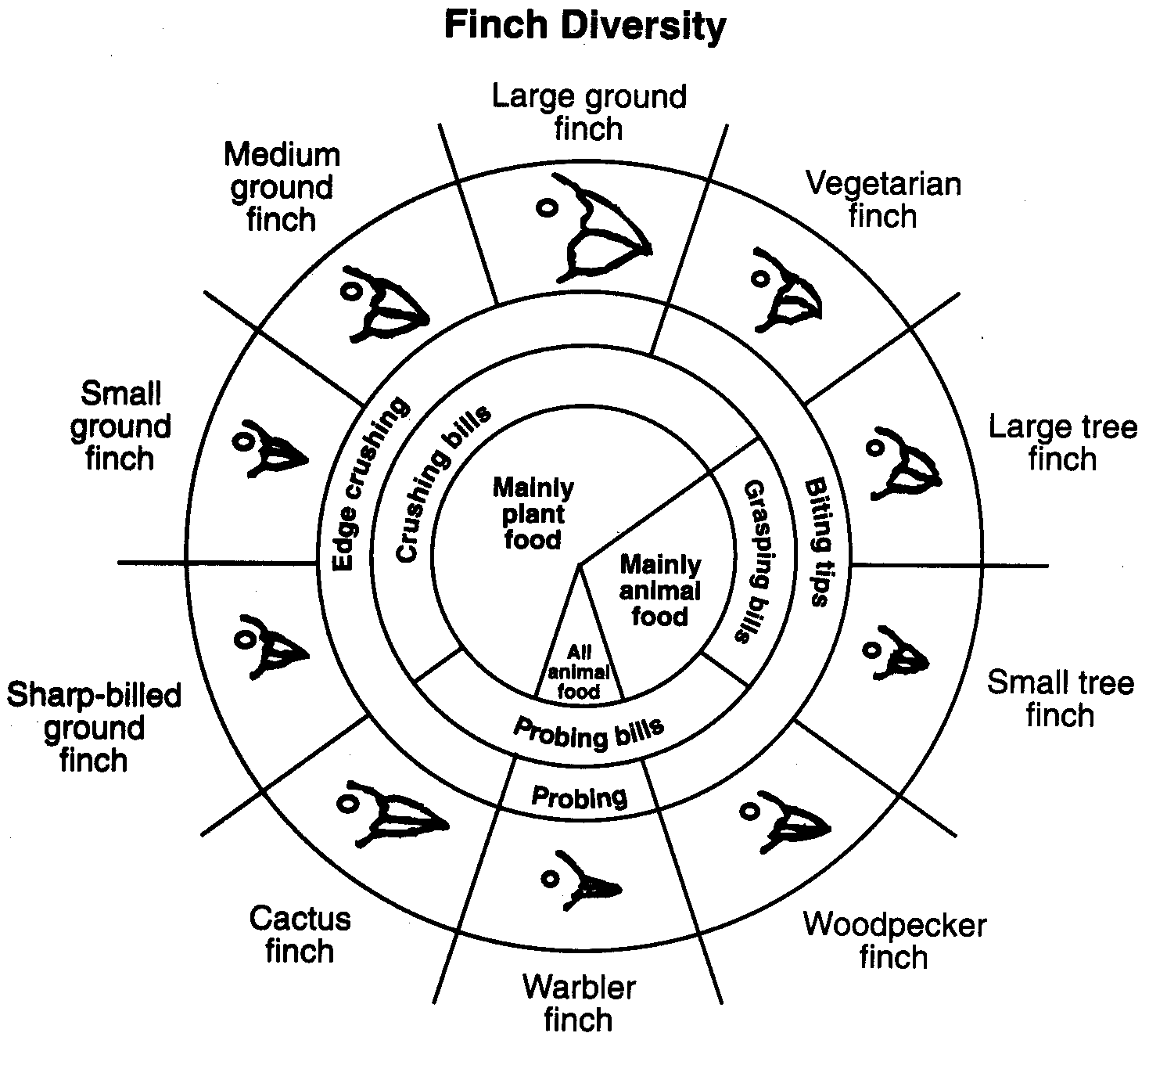

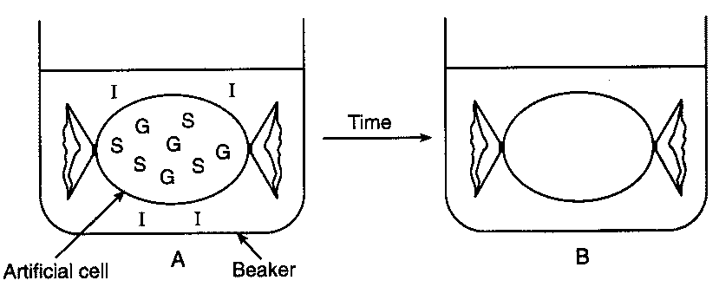

1. **Diffusion Through A Membrane**
   1. **Part A**
      1. **What you did:**
         * Made a model ______ using **dialysis tubing**.
         * Put __________ and starch inside your “cell.”
         * Put starch indicator (________) outside cell
      2. **What you saw:**
         * Inside of cell turned black because iodine _______ *into* the cell
         * Because outside of the cell was not black, you know the starch did not diffuse through the ___________.
         * Used blue glucose indicator (Benedict’s solution) to ______ that glucose did diffuse through the membrane.
      3. **What you learned**
         * _______ molecules (glucose, iodine) can **diffuse** through a membrane on their own.
         * Large molecule (starch) _____ diffuse through a membrane on their own.
         * You can use _________ to identify the presence of specific substances.

**Word Bank**

iodine indicators diffused cannot membrane cell glucose see small

* 1. **Part B**
     1. **What you did:**
        + Looked at red onion cells under the ______________.
        + 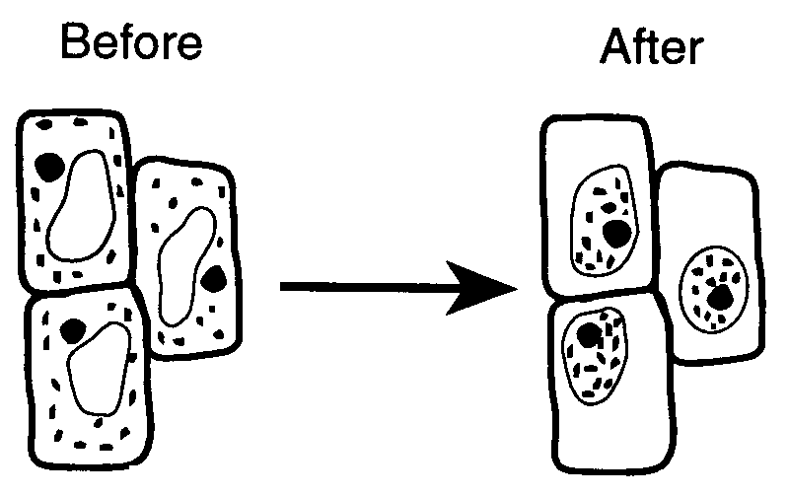Added ________ water to the onion cells.
        + Added distilled (pure) _________ to the onion cells.
     2. **What you saw:**
        + Salt water caused the onion cells to ________.
        + Distilled water caused the cells to _______ back to normal.
     3. **What you learned:** 
        + **Salt water causes water to diffuse ______ of a cell.**
        + **In pure water, water will diffuse ______ a cell.**

**Word Bank:** swell outsalt shrivel water into microscope